Kinematics for Lynxmotion Robot Arm
Dr. Rainer Hessmer, October 2009

Note: This article contains text and two graphics from the reference [1] listed at the end.

Kinematics

Forward Kinematics
Given the joint angles and the links geometry, compute the orientation of the end effector relative to the base frame.

Inverse Kinematics
Given the position and orientation of the end effector relative to the base frame compute all possible sets of joint angles and link geometries which could be used to attain the given position and orientation of the end effector.

2R Planar Manipulator
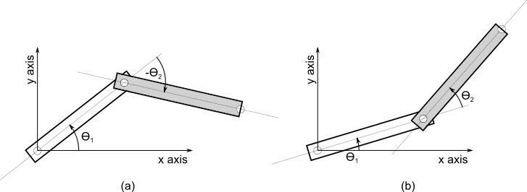
Figure 1: Elbow up (a) and Elbow down (b) configuration of a 2R planar manipulator

Forward Kinematics

Inverse Kinematics

Next we use the following equalities:

Therefore

and

From here we could get the angle directly using the arccose function but this function is very inaccurate for small angles. The typical way to avoid this inaccuracy is to convert further until we can use the atan2 function.

The two solutions correspond to the 'elbow up' and 'elbow down' configurations as shown in figure 1 a) and b).

Finally we get:

For solvingwe rewrite the original nonlinear equations using a change of variables as follows (see figure 2):

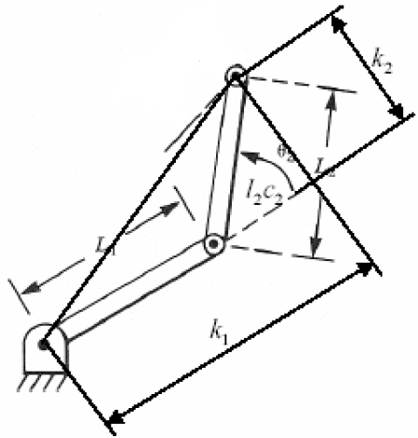

where

Figure 2 (taken from [1])

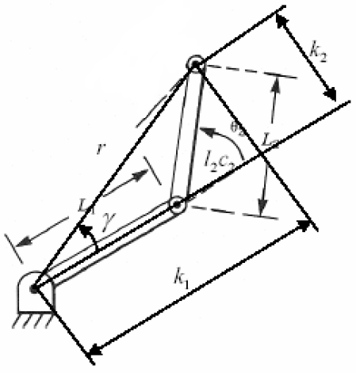
Next we change the way we write the constants(see figure 3)

Figure 3 (taken from [1])

Inserting into the previous transformations of x and y yields:

or

or

Applying the atan2 function:

where

Notes
- Switching to another choice of sign in the solution forabove will change the sign of and thus will affect.
- If x = y = 0 then the solution becomes undefined. In this caseis arbitrary. Note that this is only possible if both links have the same length and can fold back onto each other.

Inverse Kinematics for Lynxmotion Robot Arm
Here we focus on the inverse kinematics for the wrist without taking the gripper into account. This means the robot arm can be described as a 2R planar manipulator on a rotating base.

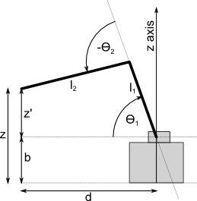

Figure 4: Side view of Lynxmotion robot arm without gripper.

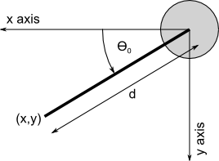

Figure 5: Top view of Lynxmotion robot arm without gripper.

The goal is to calculate the anglesfrom the position (x,y,z) of the wrist. Note that the x,y,z axes as illustrated in figures 4 and 5 do not match the default coordinate system used by the RIOS software.

The angleis fully defined by the coordinates x and y:

In order to get the other two angles we leverage the distance d of the point (x,y) from the origin and the height z' above the shoulder joint.

where b is the height of the shoulder joint (see figure 4 for details).

This allows us to use the calculations for the 2R planar manipulator. d is plugged in as the x value into the formulas forand and z' is used in as the y value.

References
- [1] MECH 498: Introduction to Robotics, Inverse Manipulator Kinematics
by M. O’Malley
http://www.owlnet.rice.edu/~mech498/498lecture4.pdf
- [2] Stanford University Course: Artificial Intelligence | Introduction to Robotics
by Khatib, Oussama
(http://see.stanford.edu/see/courseInfo.aspx?coll=86cc8662-f6e4-43c3-a1be-b30d1d179743)
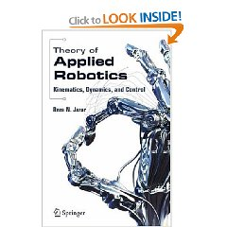
- [3] Theory of Applied Robotics: Kinematics, Dynamics, and Control
by Resa N. Jazar
(http://www.amazon.com/Theory-Applied-Robotics-Kinematics-Dynamics/dp/0387324755/ref=sr_1_1?ie=UTF8&s=books&qid=1255828006&sr=8-1)

